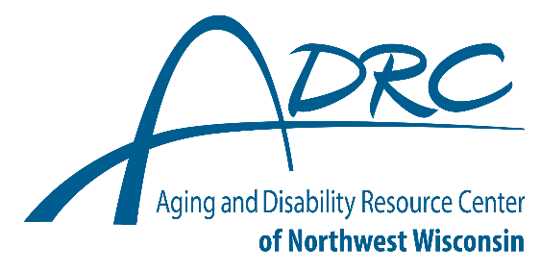
Transitioning to Adult Services:

Who to Contact and When

Key Contacts for Youth with Disabilities and Their Families

Children’s Long Term Care Waiver

Contact anytime while your child is under 18.
- For families with a child with a disability who want and need help finding and paying for services needed outside of their child’s school day, to help make school life and home life as consistent as possible.
- Burnett County: 715-349-7600; Polk County: 715-485-8400; Ask for the Children’s Waiver Worker

Mental and Behavioral Health Services

Contact at any age.
- For individuals of all ages needing mental and behavioral health support and services.
- Burnett County: Non-Emergency 715-349-7600 and Crisis Line 888-552-6642; Polk County: Non- Emergency 715-485-8400 and Crisis Line 888-552-6642

Division of Vocational Rehabilitation

Contact 2 years before your child is planning to graduate from high school.
- For anyone with any disability (disability determination not required) and needing any level of assistance with finding, getting, and keeping a job.
- Burnett County: 715-679-5577; Polk County: 715-234-6806; Tribal Member: 715-635-0967

Aging and Disability Resource Center of Northwest Wisconsin

Contact when your child is 17.5 years of age; Contact any time after that with questions related to living with a disability and resources available.
- For adults of all ages living with a disability and for older adults 60 years of age and older who need information, assistance or resources needed to live safely, with dignity and as independently as possible.
- Polk and Burnett Counties: 877-485-2372

Adult Protective Services

Contact when you child is 17.5 years of age.
- For individuals/youth needing a guardian or decision-making supports as an adult and for vulnerable adults of all ages experiencing any type of abuse or living in an unsafe environment.
- Burnett County: 715-349-7600; Polk County: 715-485-8400

Social Security Administration

Contact at 17.5 years of age to apply for Supplemental Security Income
- For disabled adults who are unable work and/or earn a certain monthly amount.
- Burnett County: 877-628-6578; and Polk County: 888-823-3923

Independent Living Centers

Contact at any age—youth or adult.
- For individuals who need home modifications, adaptive tools or equipment or addition training with activities of daily living
- Burnett County: indiGO 715-392-9118; Polk County: Center for Independent Living 800-228-3287

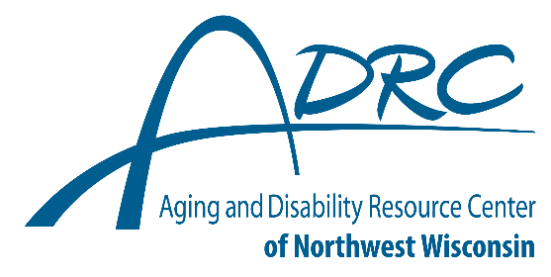
Transitioning to Adult Services:

Who to Contact and When

Key Contacts for Youth with Disabilities and Their

Families

Post Secondary Education Disability Services/ Accommodations Specialist

Contact as soon as your child begins exploring post-secondary educational institutions/ organizations.
- For college and technical school students needing accommodations to access academic programs and activities. Accommodations may include adaptive equipment, screen reading or speech to text software, or an interpreter.
- Visit www.wtcsystem.edu/technical-college-benefits/student-support/ to find appropriate contacts through the Wisconsin Technical College System.
- For a list of coordinators of services for students with disabilities in the University of Wisconsin entities, visit www.wisconsin.edu/disability-resources/contacts-resources/coordinators/.

Updated: 9/2024

