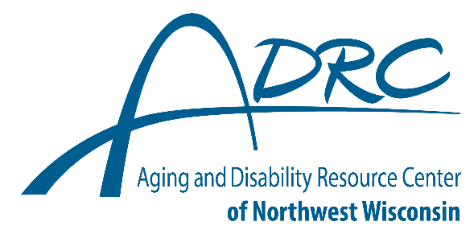
Balsam Lake Office
Polk Co. Govt. Center, 100 Polk Co. Plaza #60, Balsam Lake, WI 54810

Siren Office
Burnett Co. Govt. Center, 7410 Co. Road K #180, Siren, WI 54872
Toll Free: 877-485-2372 Fax: 715-500-6504

Transition Resource List

INFORMATION, ASSISTANCE and NAVIGATION
- The Regional Centers for Children and Youth with Special Health Care Needs
www.dhs.wisconsin.gov/cyshcn/regionalcenters.htm
- Disability Rights Wisconsin www.disabilityrightswi.org
- ABC for Health, Inc. www.safetyweb.org/

EMOTIONAL SUPPORTS and COMMUNITY CONNECTIONS
- Parent-to-Parent of Wisconsin www.p2pwi.org
- Family Voices of WI https://familyvoiceswi.org/
- WI Family Ties www.wifamilyties.org/
- WI FACETS www.wifacets.org
- Grassroots Empowerment Project https://www.grassrootprojects.org/
- Sibling Leadership Network siblingleadership.org/
- Wisconsibs wisconsibs.org
- Wisconsin Board for People with Developmental Disabilities http://www.wi-bpdd.org

Legal and Financial Considerations
- The Arc’s Center for Future Planning futureplanning.thearc.org/
- Supported Decision Making (A Family Voices Fact sheet) https://familyvoiceswi.org/resource- library/supported-decision-making-for-transition-age-youth/
- National Resource Center for Supported Decision Making – www.supporteddecisionmaking.org
- Wisconsin Guardianship Support Center www.gwaar.org/for-seniors-and-families/elder-law-and- advocacy-center/wisconsin-guardianship-support-center.html
- What is a Special Needs Trust? specialneedsanswers.com/what-is-a-special-needs-trust-13601
- ABLE National Resource Center www.ablenrc.org
- Advance Directives Forms (from WI DHS) www.dhs.wisconsin.gov/forms/advdirectives/ index.htm
- Planning Ahead for Future Health Care Needs https://marketplace.wisbar.org/store/products/publications/gc0333-a-gift-to-your-family- minnesota-version/c-25/c-84/p-17509

HEALTH
- Health Transition Wisconsin www.healthtransitionwi.org/
- Covering Wisconsin www.coveringwi.org
- National Health Care Transition Center (Got Transition) www.gottransition.org/
- Health Care Transition Checklist https://ucedd.waisman.wisc.edu/products/transition-health-care-checklist-preparing-for-life-as-an-adult/
- My Health Pocket Guide https://ucedd.waisman.wisc.edu/my-health-pocket-guide/

Balsam Lake Office
Polk Co. Govt. Center, 100 Polk Co. Plaza #60, Balsam Lake, WI 54810

Siren Office
Burnett Co. Govt. Center, 7410 Co. Road K #180, Siren, WI 54872
Toll Free: 877-485-2372 Fax: 715-500-6504

EDUCATION
- PACER Center Information Sheet on the ADA, Section 504 and Postsecondary Education
- https://www.pacer.org/parent/
- Transition Action Guide – For Post School Planning https://dwd.wisconsin.gov/dvr/policy-guidance/toolkits-guides-manuals/transition-action-guide/
- Transition Improvement Grant www.witig.org/
- Department of Public Instruction https://dpi.wi.gov/sped

Department of Public Instruction Opening Doors to Postsecondary Education
https://dpi.wi.gov/sites/default/files/imce/sped/pdf/tranopndrs.pdf
- Wisconsin Statewide Parent Educator Initiative http://wspei.org

Employment
- Wisconsin Division of Vocational Rehabilitation https://dwd.wisconsin.gov/dvr
- Let’s Get to Work http://www.letsgettoworkwi.org

Youth in Transition (Department of Health Services Employment website)
www.dhs.wisconsin.gov/clts/waiver/transition/youcanwork.htm

Department of Public Instruction Opening Doors to Employment
dpi.wi.gov/sites/default/files/imce/sped/pdf/tranopndrs-employmt.pdf
- Employment Resources, Inc. - www.eri-wi.org/
- Wisconsin Employment First https://wi-bpdd.org/index.php/employment-first/
- Project SEARCH http://www.projectsearch.us/

College Resources
- College Resources for Students with Disabilities https://www.affordablecollegesonline.org/college- resource-center/resources-for-students-with-disabilities/
- Parental Support For College Students http://www.onlinecolleges.net/for-students/resources-for- parents/
- College Affordability Guide http://www.collegeaffordabilityguide.org/schools/wisconsin/

The Fully Accessible Guide to Paying for College for Students with Disabilities https://www.goodcall.com/education/fully-accessible-guide-paying-college-students- disabilities/

25 Great Scholarships for Students with Learning Disabilities
https://www.top10onlinecolleges.org/scholarships-for/students-with-learning-disabilities/
- CPRCertification.com-https://www.cprcertification.com/disability-scholarships
- MoneyGeek.com - https://www.moneygeek.com/financial-planning/paying-for-college/scholarship-resources/students-with-disabilities/

aRealOnlineDegree - Students with Disabilities: 2017 Resource Guide http://arealonlinedegree.com/college-resources/resources-students-disabilities/.

These Resources and Links are from:

https://familyvoiceswi.org/learn/#whats-after-high-school

https://www.witig.org/resources-for-parents.html

